**Restaurant-Cafe Automation**

- “Table Order” screen where table orders and status of tables can be observed

- "Package Order" screen, where you can easily make package orders and save existing orders

- “Reservation” screen where reservations can be kept by day, hour and table

- “Customers” screen where we can keep our customer list and important addresses, phones

- "Kitchen" screen showing when the order sent to the kitchen went, what went and the order status

- “Cash Transactions” screen, where the table, amount, discount, regular and partial payment, bill printing operations can be made for paid, unpaid, canceled, closed orders

- “Reports” screen, where sales rates can be viewed according to the selected date ranges, bills, sales, products, kitchens, waiters and wages.

- A smart "Inventory Tracking" screen that can monitor stock and warn when the product reaches critical levels (Development of this menu has not been completed, it is in progress.)

- “Settings” screen where settings such as receipt and invoice arrangements, discount rate, logo can be made

- “Definitions” screen where user roles, usernames and passwords can be given, table and product definitions can be made.

- "Notes Reminders" screen where various notes can be kept

- We decided that our needs could be met by creating screens such as the "Calculator" screen, in order to be able to calculate without leaving the screen.

In addition, it has been made with the latest technological software so that the software is web-based, compatible with various tablet and touch devices, and can be monitored not only inside the restaurant but also outside the restaurant.

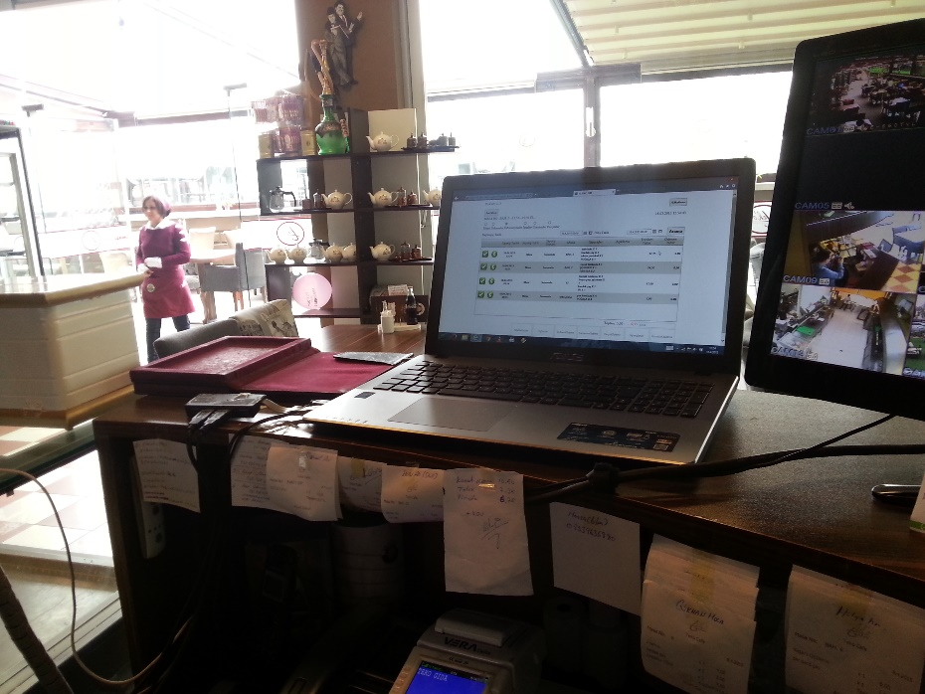

**Thermal printers that can quickly print bills that can show the content and price of the order given to the kitchen and the customer**

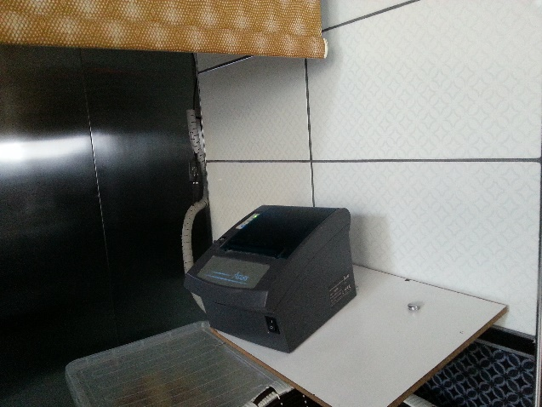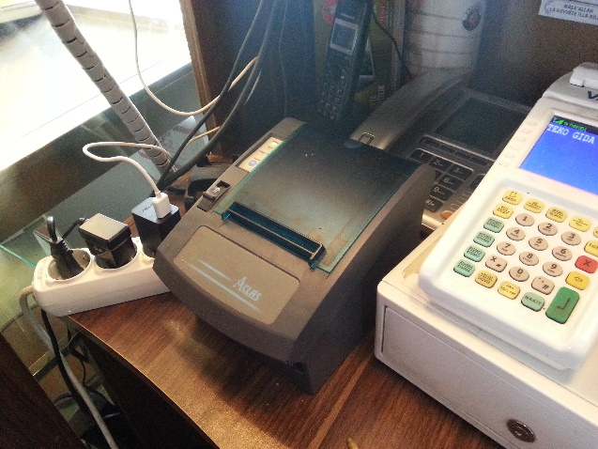

**Hand terminals where order takers can freely enter their orders from anywhere they want, without leaving the customer's side.**

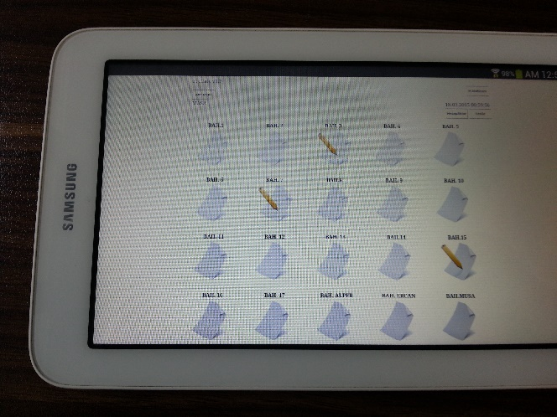

**"Login” screen. In addition, device selection and related screen adjustments are made from this screen.**

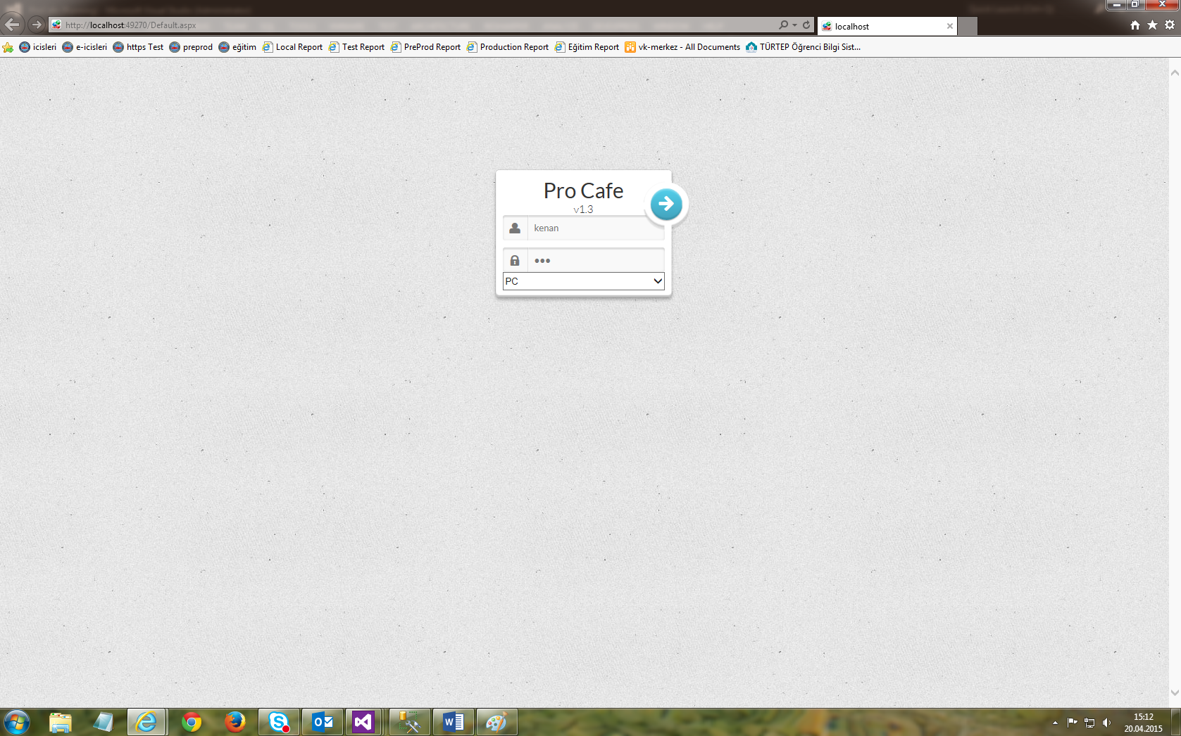

After the user login, we encounter the "Main Menu". Here, there are screens where the user can log in according to his authority.

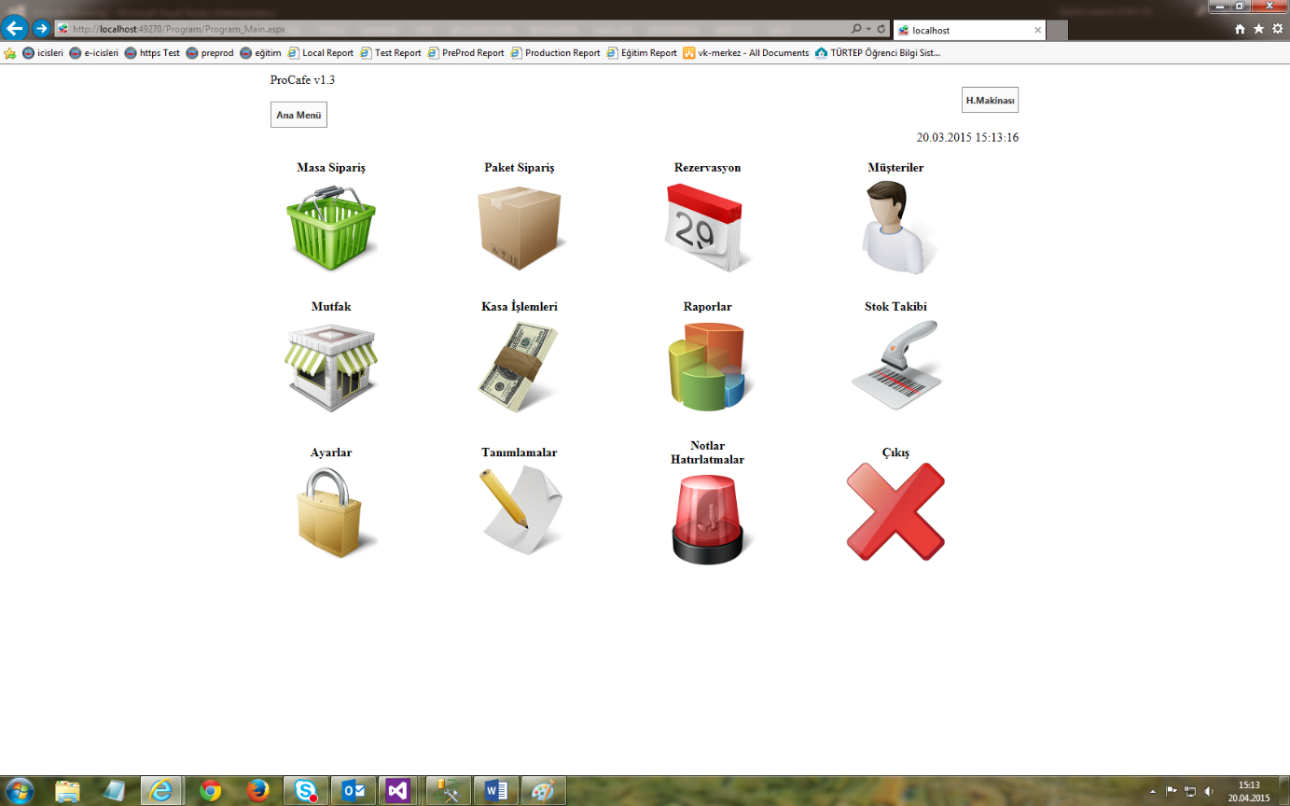

**“Table Order” screen. Here we can see the open and closed tables and the orders placed, and make changes.**

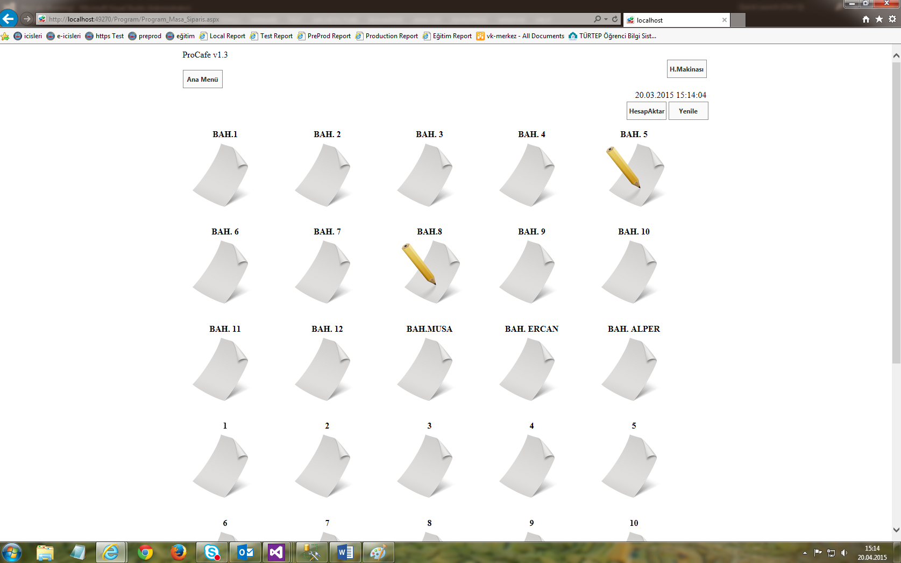

**In the "Order" menu, orders placed for that table, prices, products according to categories, and adding and subtracting operations are performed on these products.**

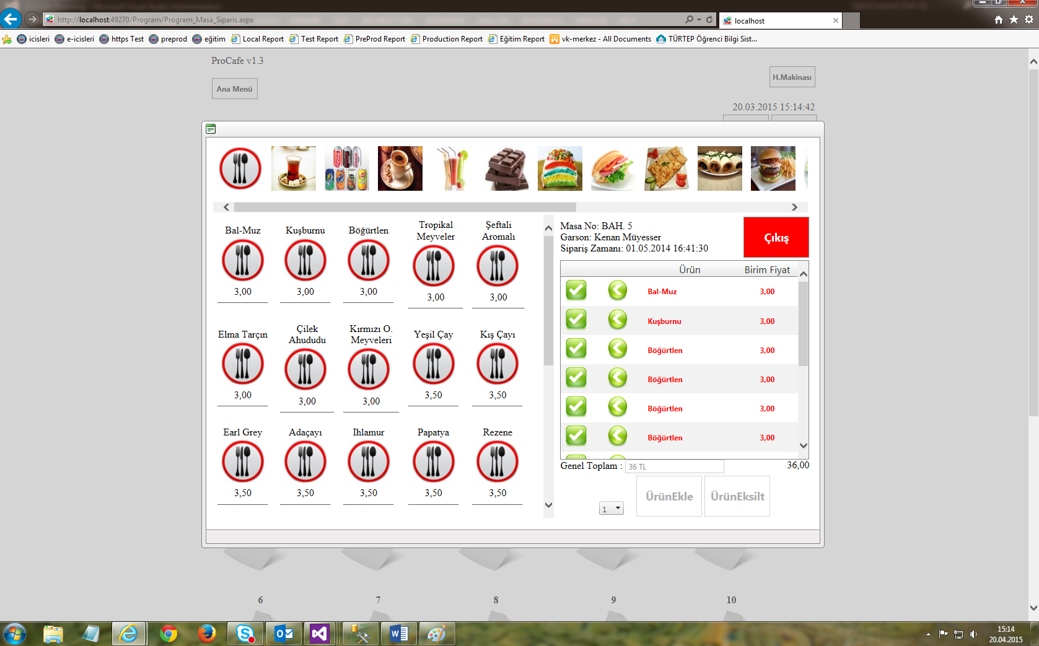

“Package Order”, “Reservation”, “Customers” and “Notes Reminders” screens, respectively. They are very similar to each other in structure. Logs of the menu function are recorded and viewed, deleted, changed and searched.

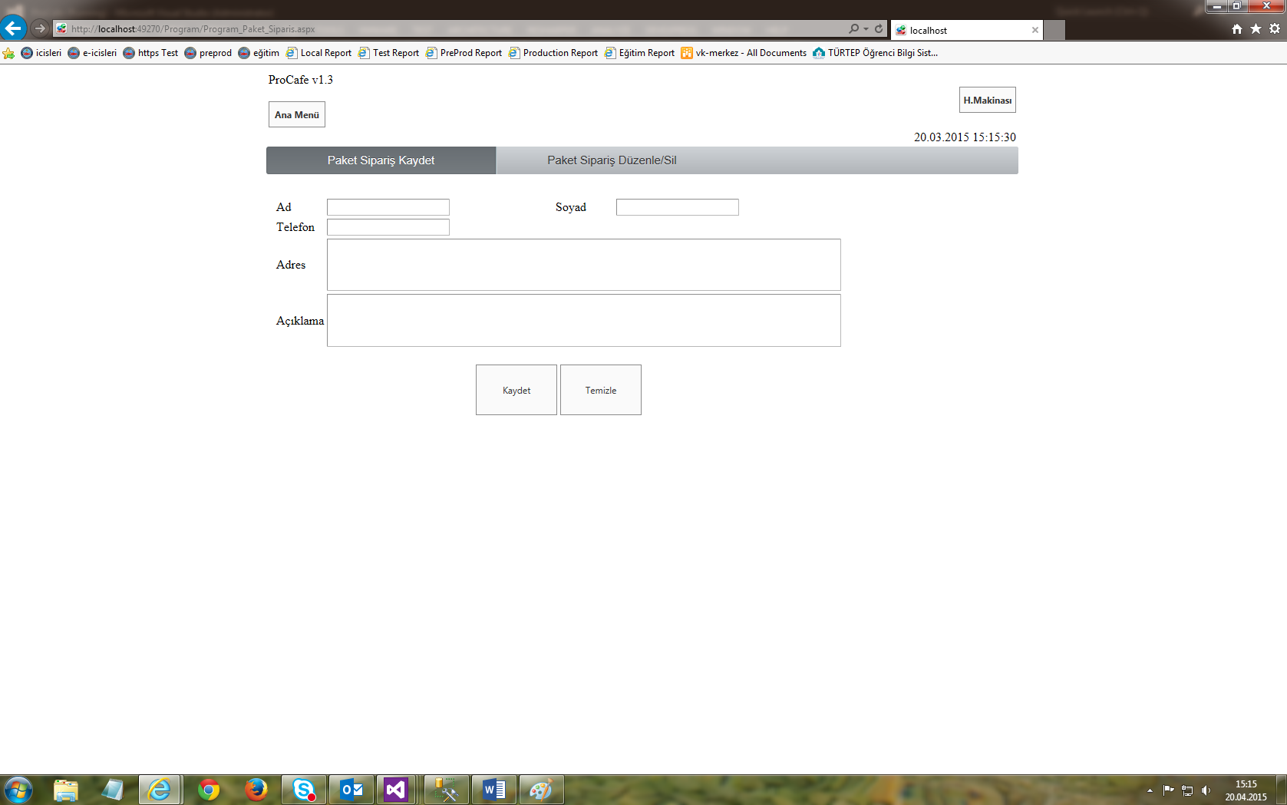

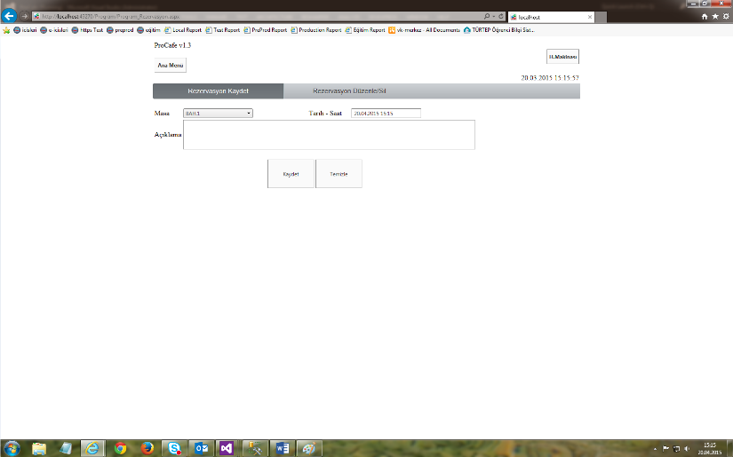

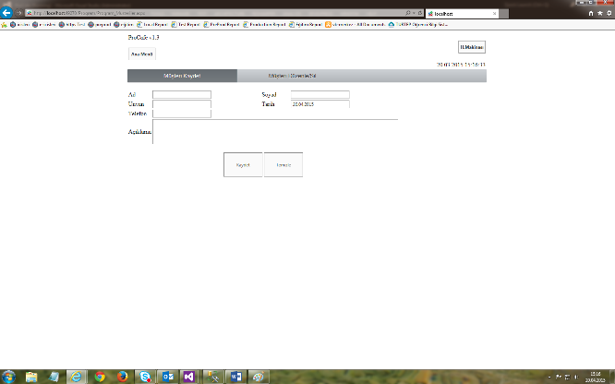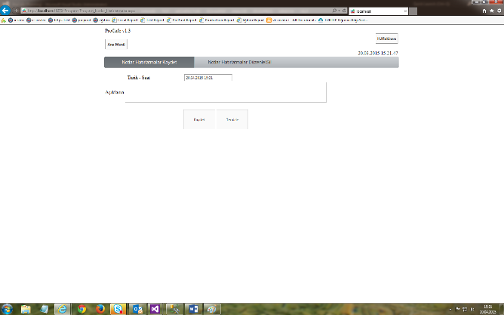

**On the “Kitchen” screen, you can view the orders sent to the kitchen, which ones are in service or in the waiting phase. Used by the kitchen crew and the cashier.**

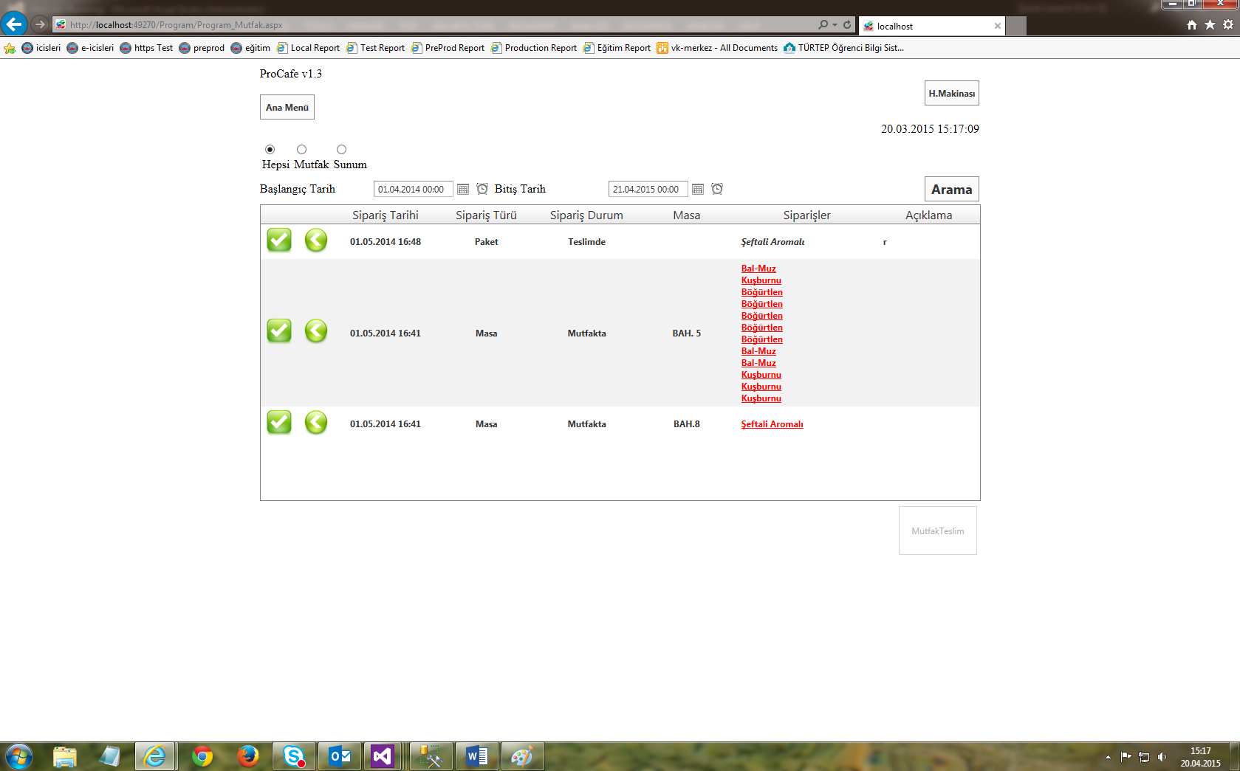

**It is the screen used by the person standing at the cash register, where it is monitored which desk has placed which orders on the “Cash” screen, the amount, discounted, partial and regular payments are made, transactions such as printing bills are made.**

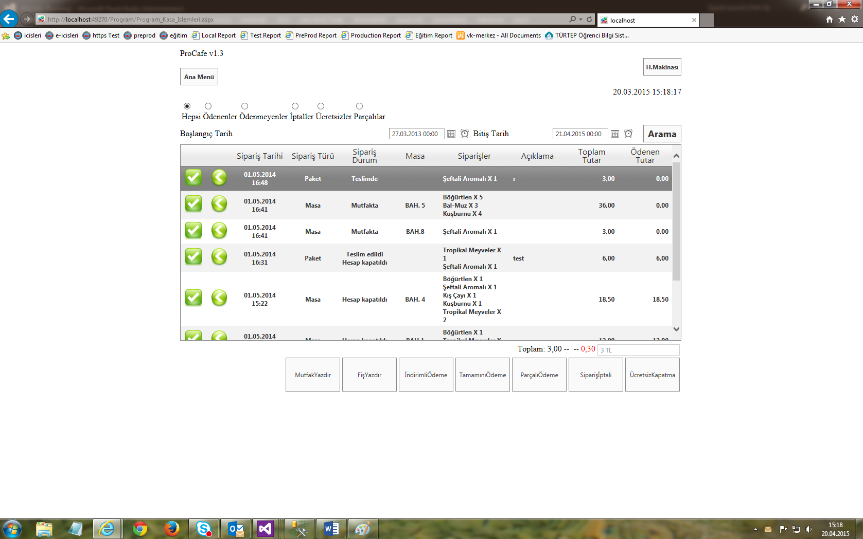

“Print Receipts and Tickets” screen within the cashier screen. Here, the content and amount of the order placed with the company's logo are displayed. This screen is printed on paper by means of a thermal printer.

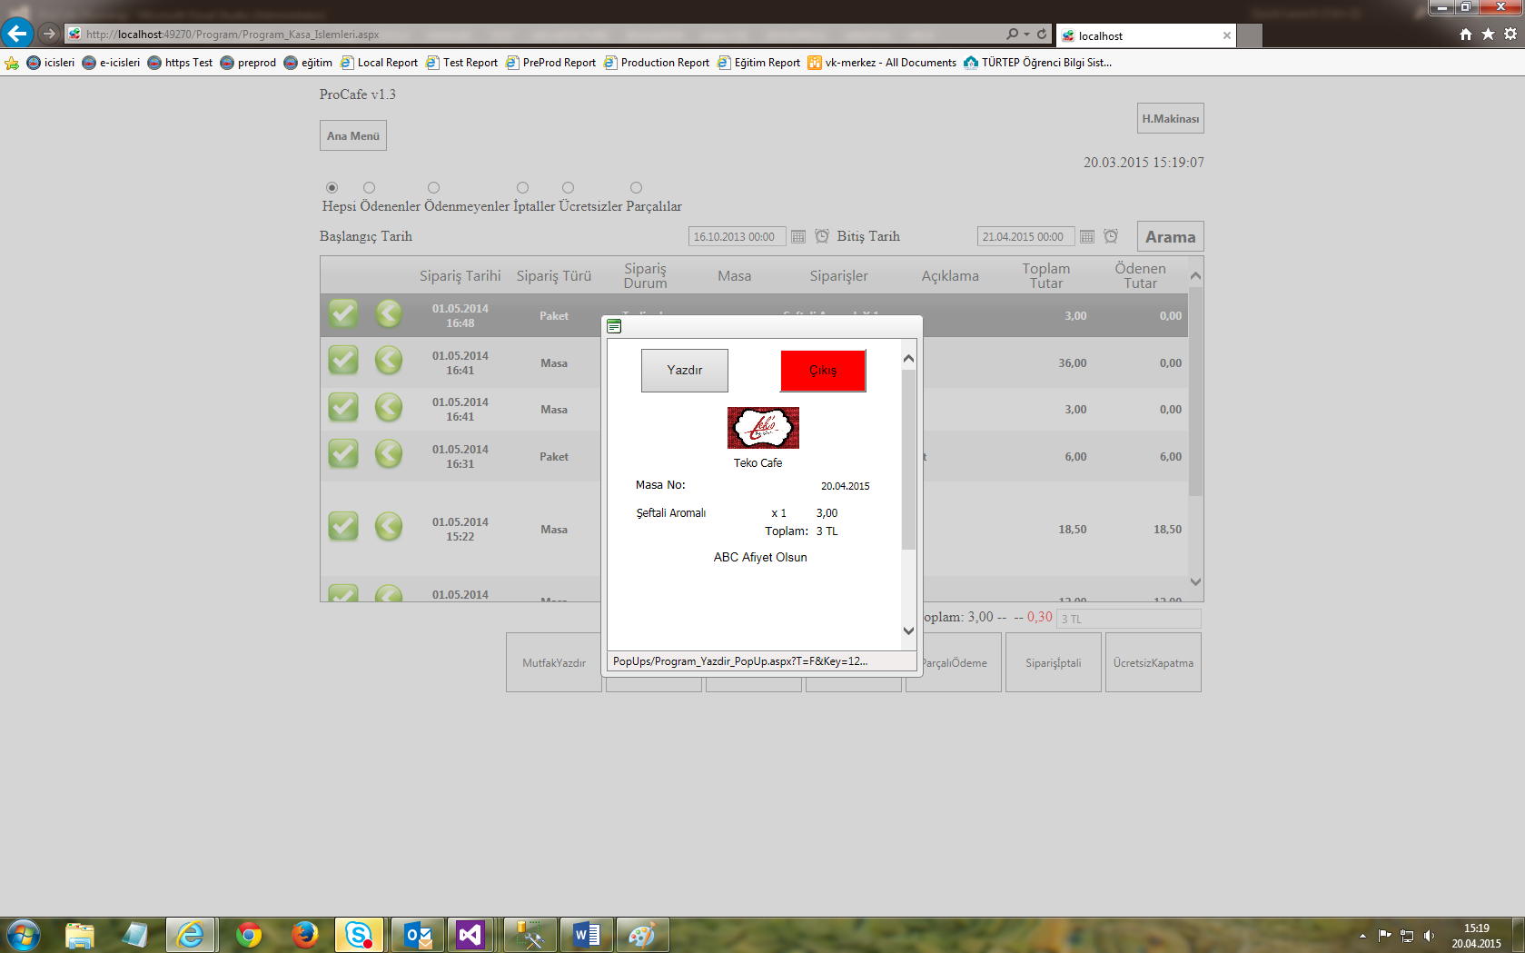

**There are screens where bills, end-of-day reports and sales-related reports can be received in the date ranges determined on the “Reports” screen.**

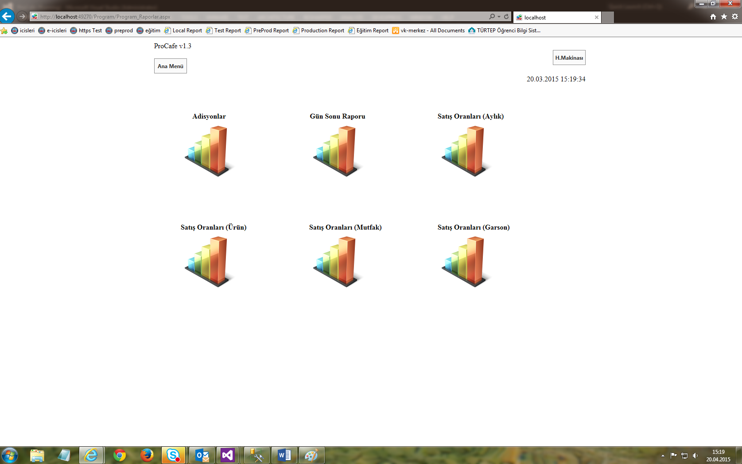

An example report. Here you can both view and print, excel and pdf.

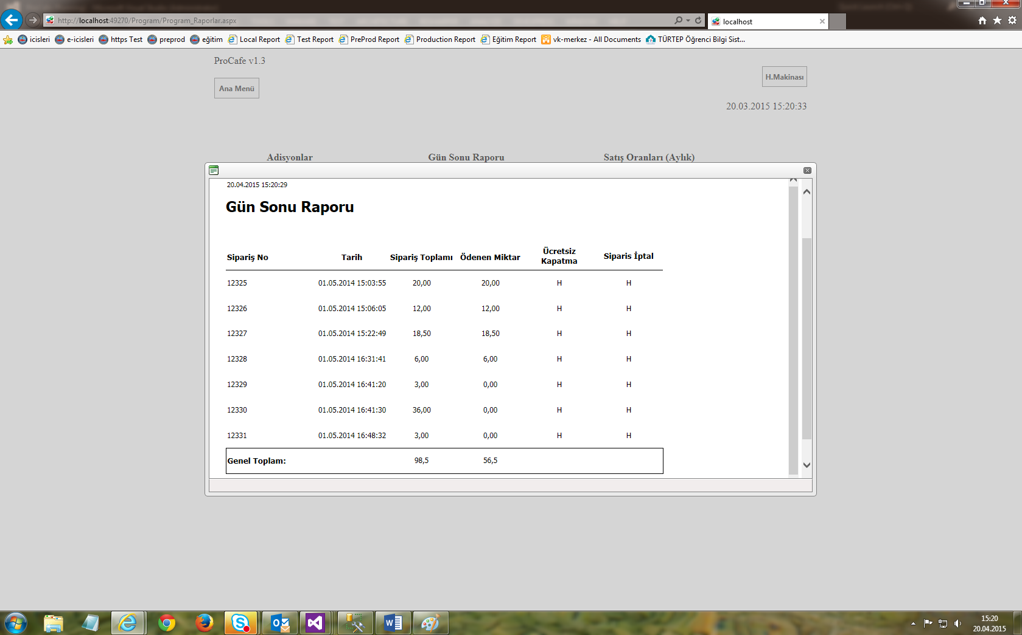

**On the "Settings" screen, bill, discount rate, printout settings can be made.**

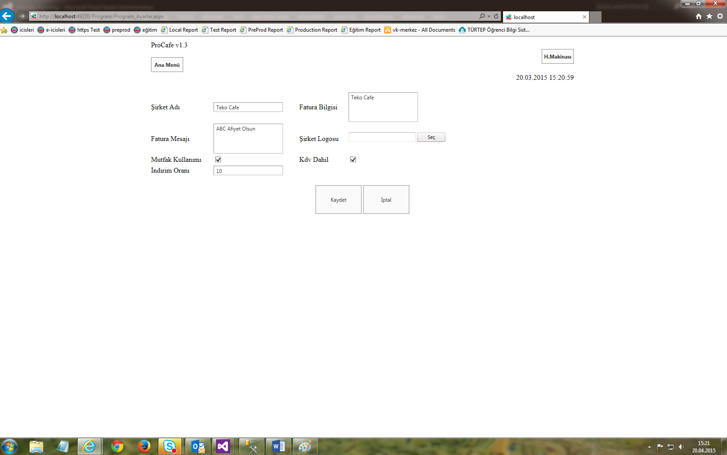

**On the "Identification" screen, user and authorization, table, category, product definition operations are performed. Modifications and deletions can also be made here.**

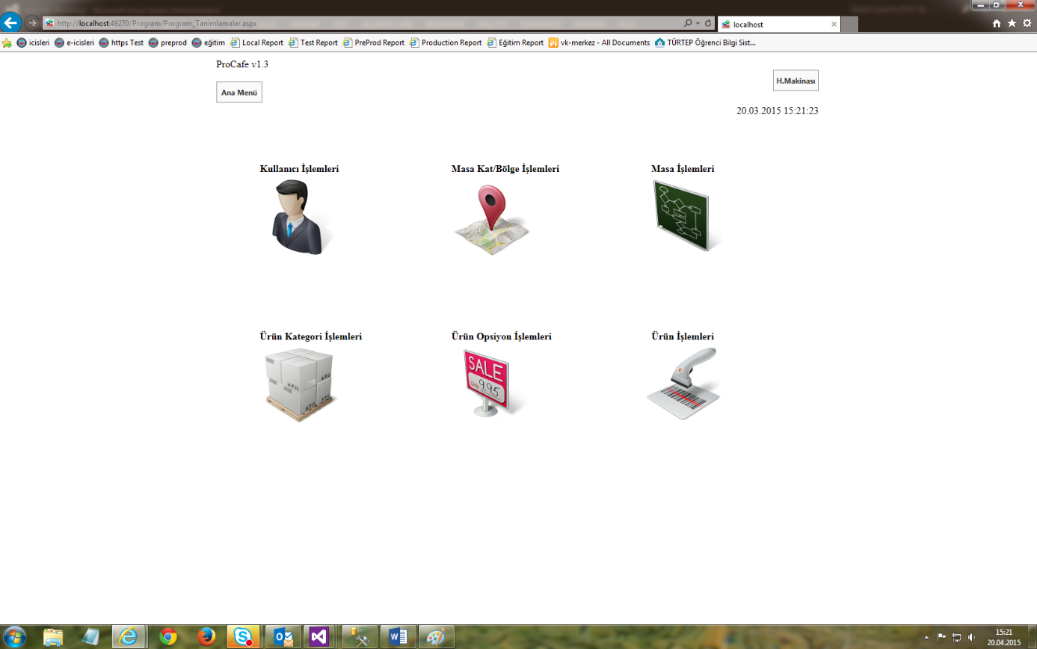

**With the "Calculator", necessary calculations can be made without leaving the screen.**

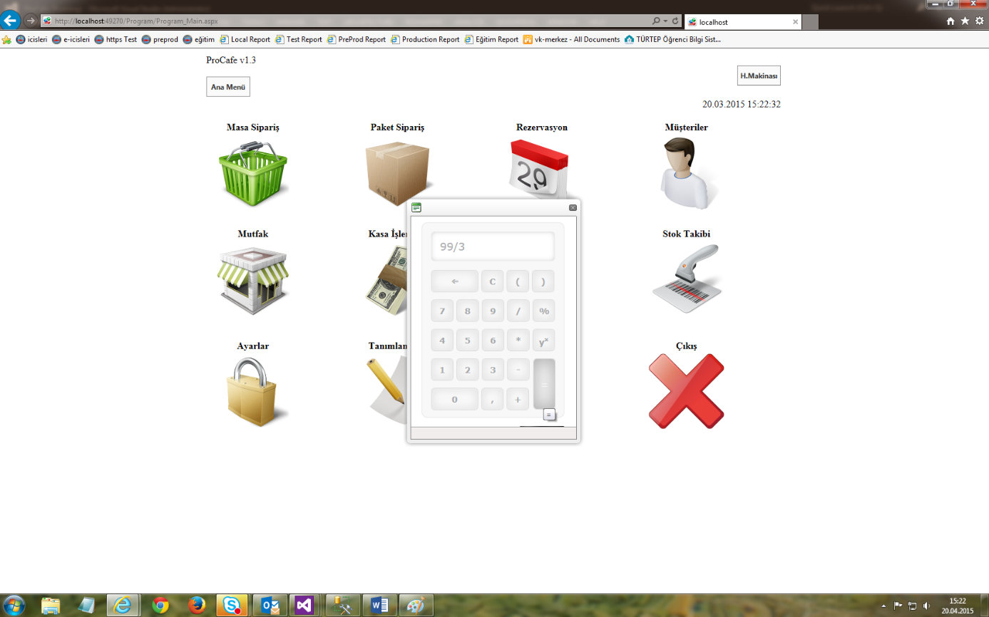

**Mobile Screens (Handheld Terminal Screens)**

Menu design fully compatible with ipod touch and android devices. It is designed for staff who can take orders for the table. They can take the order without leaving the customer's side.

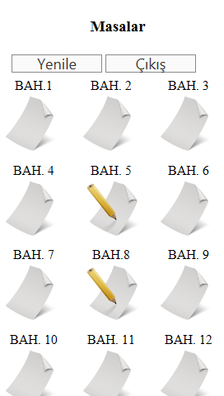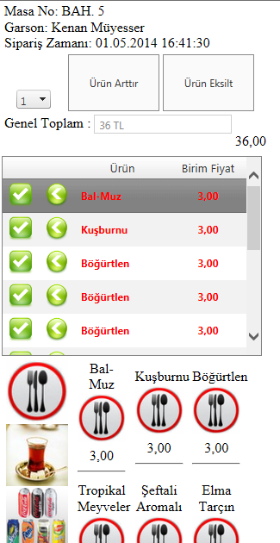

Kitchen printer (thermal). It prints out the orders sent to the kitchen and informs the kitchen staff that a new order has been placed. This output is taken from the cash register screen.

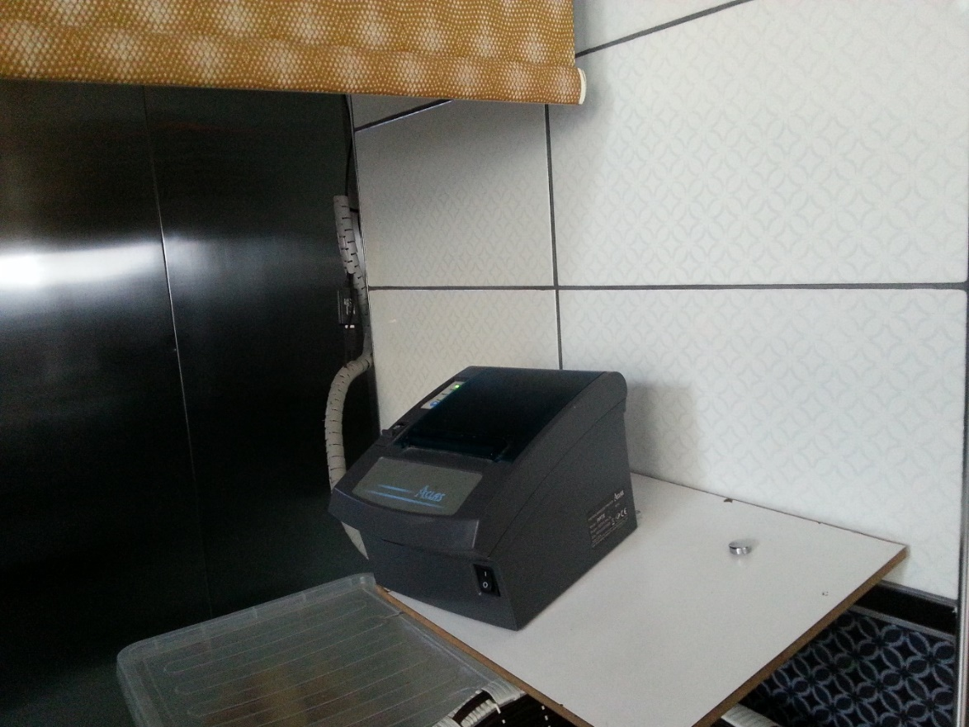

Cashier ticket printer prints bills for the customer. This output is taken from the cash register screen.

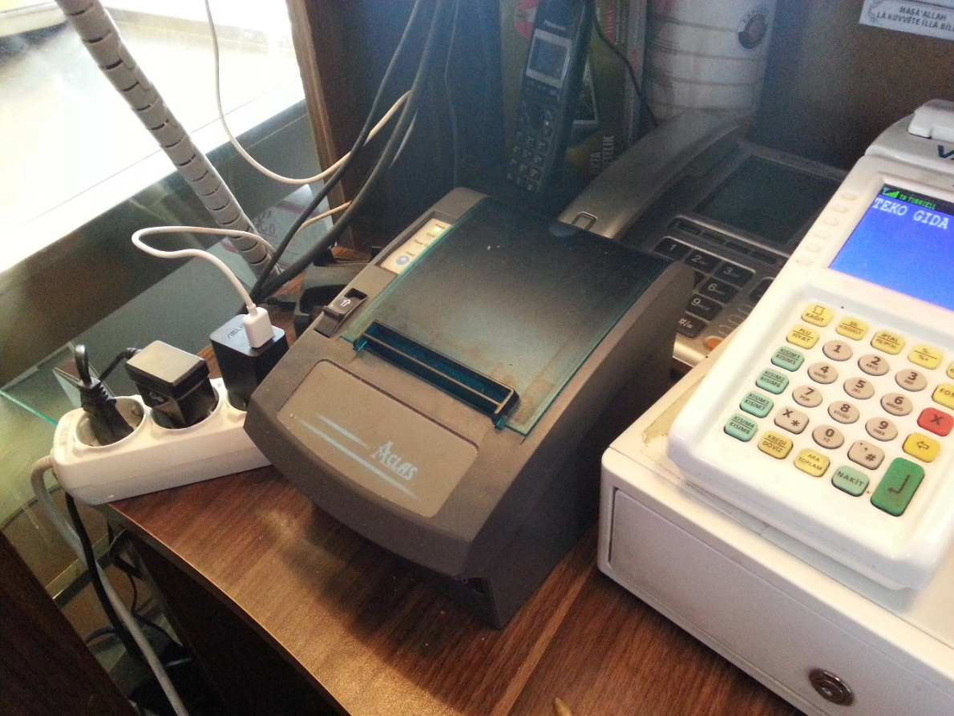

A computer equipped with the necessary hardware to keep a safe account and run programs. It is the server computer to which all machines (mobile handheld terminals and thermal printers) are connected (wireless or wired).

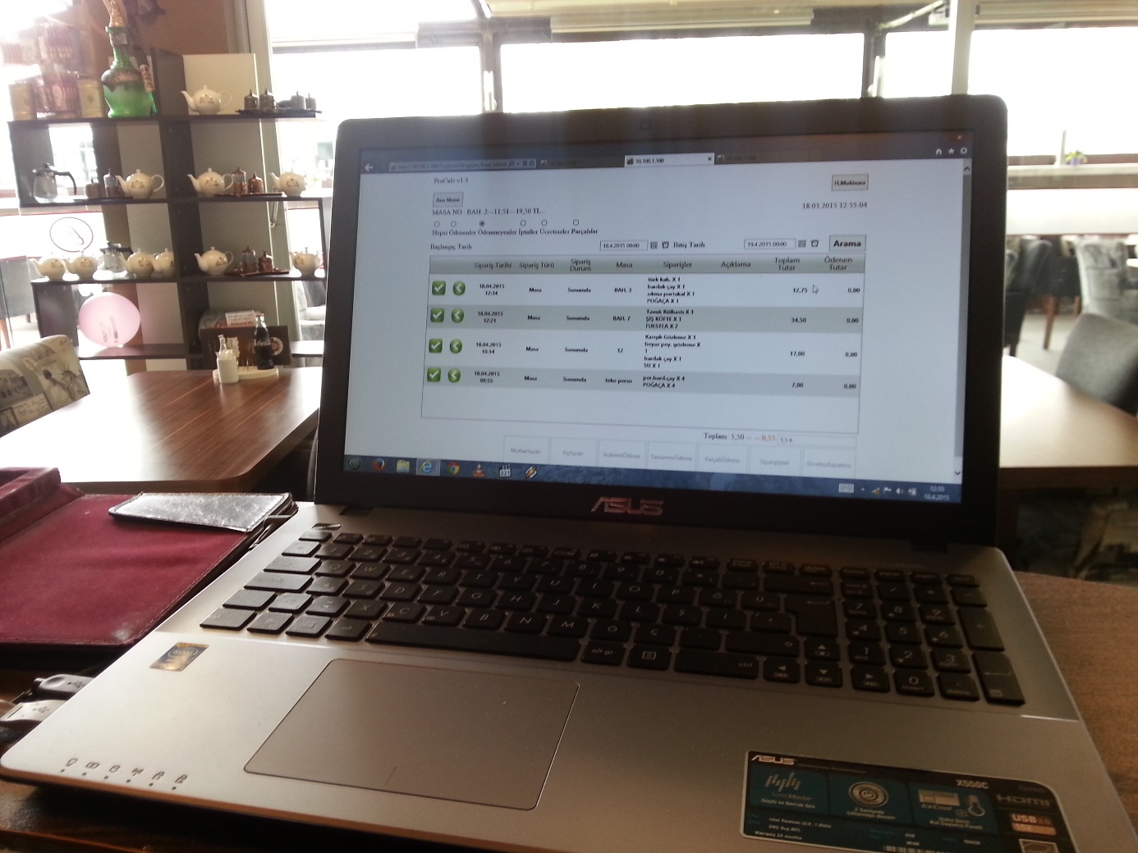

Handheld terminals with Android operating system. With these, we create a low-cost system that can be used not only by order takers but also by kitchen staff. It is a 60% more cost-effective system than its counterparts.

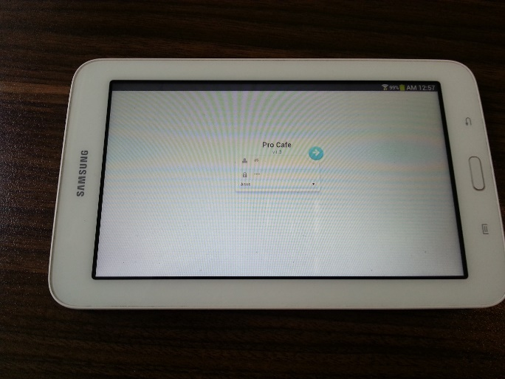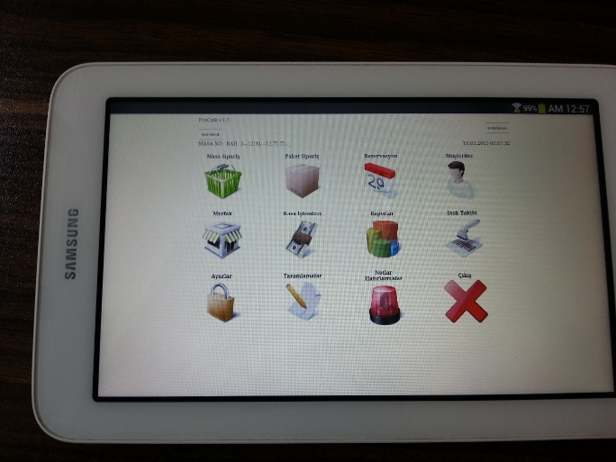

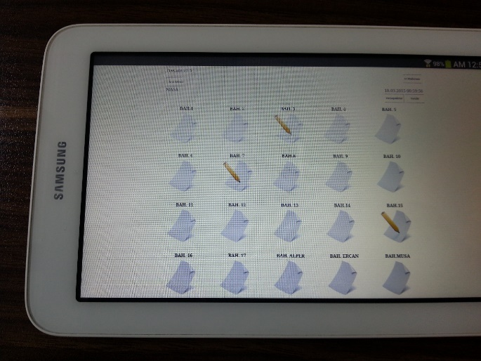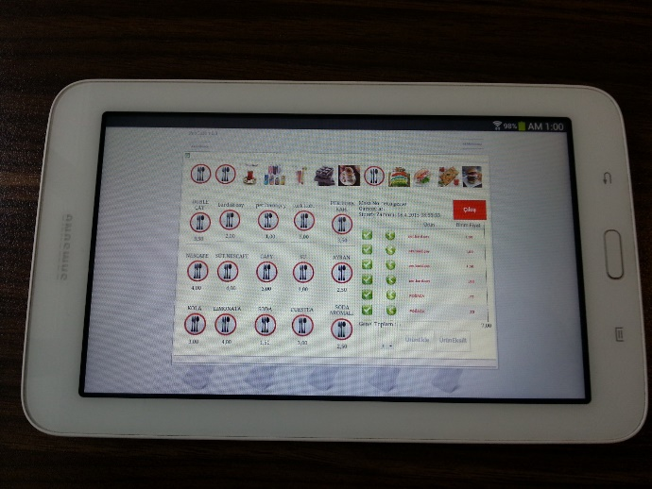

Database Tables

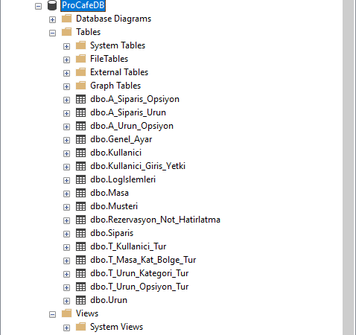

Database Diagram

